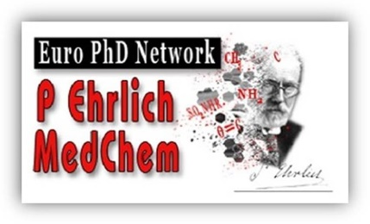

Template for PE MedChem Euro-PhD Certificate

PhD
Candidate
Promoter(s)
Home university
Titel of PhD thesis

Promotion date
Foreign PhD referee or committee member from the PE network

Publications

numbers
Published
In press or accepted
First author

details
 | DOI number | Impact factor* | Ranking* | Quartile*
1)
2)
3)
4)
Add additional rows if necessary

* In year of publication or, when not yet available, most recent

patent application
 | Title | Inventors | Patent number*
1)

* If not yet available, add proof of submission

International mobility
Host institution | Host supervisor | Starting date (dd/mm/yyyy) | End date  (dd/mm/yyyy)

Brief description of the research work performed (max 100 words)

Paul Ehrlich meeting(s) attended
Edition (year) | Poster or oral | Title

Courses attended
Title | Place | Date

In case the number of first-author publications is less than 2, an explanatory letter by your supervisor is mandatory.
A letter from the host supervisor to certify your foreign stay is mandatory.

